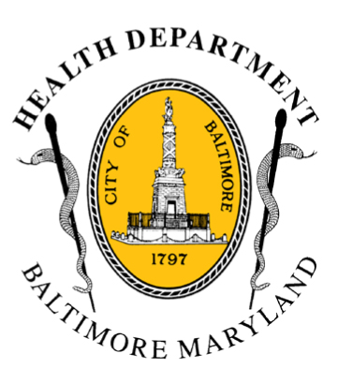
BCHD PRESS RELEASE
Baltimore City Health Department
1001 E. Fayette Street • Baltimore, Maryland 21202
Stephanie Rawlings-Blake, Mayor
Leana Wen, M.D., Commissioner of Health

FOR IMMEDIATE RELEASE

Media Contacts:

Michael Schwartzberg, PIO - O: (443) 984-2623 C: (443) 462-7939 E: michael.schwartzberg@baltimorecity.gov
Jennifer Fuson, Communications Specialist - O: (410) 545-0823 E: Jen.Fuson@baltimorecity.gov
Mayor’s Heroin Task Force Calls for Citywide Overdose Plan, 24/7 Access to Addiction Treatment, and Public Education Campaign to Fight Stigma

City Unveils “DONTDIE.ORG” Website & Campaign For Preventing Overdose Deaths

BALTIMORE, MD (July 13, 2015) - The Mayor’s Heroin Treatment and Prevention Task Force today called for 10 bold steps to attack the city’s epidemic heroin and opioid addiction, including having 24/7 “treatment on demand” for substance users and a public education campaign to encourage treatment and combat stigma.

Convened by Mayor Stephanie Rawlings-Blake in October 2014, the Task Force was co-chaired by Bernard J. McBride, CEO Behavioral Health System Baltimore, and Dr. Samuel Ross, CEO of Bon Secours Baltimore Health System, and was comprised of 35 community leaders, public health experts and government representatives. The full report can be found on the Baltimore City Health Department website, http://health.baltimorecity.gov and the Behavioral Health System Baltimore website, http://www.bhsbaltimore.org.

“This report is an important blueprint for improving the city,” said Mayor Rawlings-Blake. “Heroin is a problem that affects not just those who use the drug but all of us. Now is the time for bold and decisive action. My city agencies and local partners are already hard at work on implementing these recommendations. I call upon our state and federal leaders to work with us as we fight the heroin epidemic in Baltimore.”

“Baltimore has never taken a back seat to public health, especially not when it comes to the critical problem of heroin and opioid addiction that ties into the very fabric of our city,” said Dr. Leana Wen, Baltimore City Health Commissioner. “This is literally a matter of life and death, and we knew that we could not wait to implement the Task Force’s important recommendations. The Baltimore City Health Department has already taken the lead to convene our partners throughout the city and state to reduce heroin use, prevent overdose deaths, and improve access to addiction treatment.”

Among the Task Force’s 10 recommendations that the Baltimore City Health Department and its partners have begun to implement are:
- more-
2-2-2
- Implementing a Citywide Heroin Overdose Plan that focuses on saving lives. This plan focuses on “hotspotting” to target treatment and strategies for those most at risk for overdose and ensuring widespread dissemination of the opioid antidote, naloxone.
- Developing a data-tracking system to provide timely information about the number of people with substance use disorders, fatal and near-fatal overdoses and the city’s overall capacity to provide drug treatment.
- Implementing an outreach campaign to educate people about substance use, de-stigmatize those who have substance use disorders and urge people with problems to seek treatment.

Being unveiled today is a public education campaign about overdose prevention. Via billboards, bus shelter ads, a new website (dontdie.org) and social media, the campaign will inform the public that naloxone can save lives and that everyone should be trained to administer it.

The City is beginning to work on recommendations focused on promoting better partnership and collaboration in the community, including developing standardized good neighbor agreements between substance abuse disorder providers and community members and coordinating efforts with treatment providers and law enforcement.

Other key recommendations call upon the city to work towards 24/7 access to addiction treatment, specifically to:
- Develop an easy-to-access 24/7 intake system with immediate access to addiction counselor or social worker.
- Organize universal case management and access to treatment for the most vulnerable in the city including inmates and recently incarcerated individuals, focusing on evidence-based treatments including buprenorphine.
- Work toward “treatment on demand” including developing a 24/7 walk-in treatment center for individuals with substance abuse and mental health concerns and increasing the number of treatment slots in both inpatient and outpatient settings.

City officials will look to private partners as well as the state and federal government to assist with funding for these Task Force recommendations. An estimated $20 million is needed over three years to accomplish these goals.

There were 303 total drug and alcohol overdose deaths in Baltimore City in 2014, compared with 246 in 2013, a 23 percent increase. Last year, 192 overdose deaths were heroin-related, compared with 150 in 2013. There are an estimated 18,900 individuals who use heroin in Baltimore.

###

